Business Process Modelling – ADDING VALUE TO BUSINESSES
SOA and BPM
Leveraging SOA effectively requires implementation of a BPM engine in the integration level where all the channel systems come together with the core application.
BPM’s top-down model-initiated approach is a catalyst for SOA rollout by fostering business-IT alignment with concrete performance metrics encouraging an iterative approach to the production implementation.
Both are robust and introduce automated service management controls and tracking capabilities.
You have services in my processes: says BPM to SOA
You have processes in my services: says SOA to BPM
Both concepts are distinct yet complementary.
SOA is closer to IT
SOA defines the how of IT consumption by business.
Common to both approaches:
The concept of lose coupling
Both encourage reuse.
Both are adaptable to changing the needs of prevailing competitive environment.
Loosely coupled components rather than tightly integrated at the design time.
How BPM adds value to a business
BPM defines the IT consumption process.
BPM promotes model-based definitions.
BPM promotes prioritization of services.
It avoids wasting time and money on business irrelevant systems.
BPM promotes collaborative tools used by both business and IT to increase the velocity of communications across the enterprise.
More recently, there is generally a fine line between SOA, BPM and EA.
BPM and EA are tighter by heritage to business

PIE CHART ON COMPANIES IMPLEMENTING BPM AND THEIR RESPECTIVE ROI
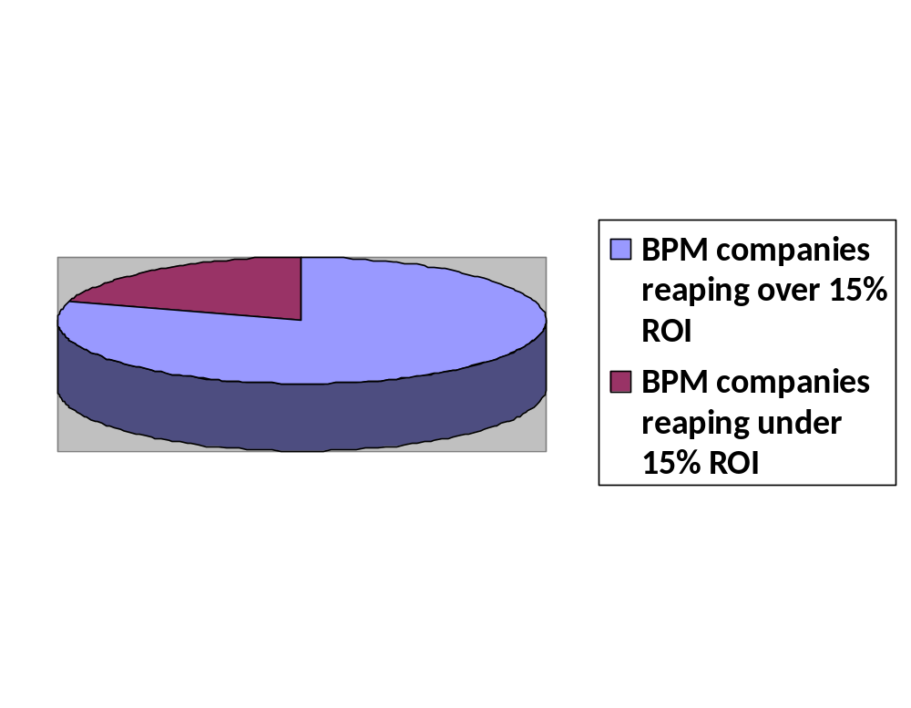
Conclusion
Companies implementing BPM experience tremendous yields in terms of ROI. Implementing a BPM engine at the integration level leveraging SOA effectively, will double the ROI of a business.

